Community Insights: Designing Your Research with Assistance from AI
A Nature Masterclasses webinar

- At which stages of the research design process can AI be most useful?
- What are the limitations of AI as a tool when designing your research?
- How should I approach institutional or funder expectations around AI use in research planning?


CC/peopleimages.com

Artificial intelligence (AI) is reshaping how research questions are developed, studies are designed, and methodologies are refined. Used well, AI can help you explore existing literature, spot patterns and strengthen research design. But it also raises important questions about bias, transparency, reproducibility, and the risk of over-relying on automated tools.

Many researchers are still figuring out how to use AI confidently and responsibly. Where does AI genuinely add value? What needs to be documented and how? And how do you balance efficiency with your own critical thinking and subject expertise?

In this webinar, you’ll learn from distinguished panellists with expertise across AI research, editorial practice, and policy. Together, they’ll explore current approaches, emerging expectations, and practical ways to use AI in research design, whether you’re just starting to experiment or already integrating AI into your workflow.
You will have the opportunity to submit your own questions when you register. Please keep them relevant to the topic of designing your research with assistance from AI. Covered topics will help you to:
- Understand how AI can support different stages of research design, from research question development to methodology
- Evaluate opportunities and limitations when incorporating AI tools in the design process
- Identify key risks of using AI – such as bias, reproducibility issues, and over-reliance – and approaches to mitigate them
- Apply AI in ways to strengthen, rather than replace, your own critical thinking and research expertise.

Session timings
(please register for one session only):

Time | Registration link
Wednesday 10th June, 12:00–1:00 PM EDT | Here
Thursday 11th June, 9:00–10:00 AM EDT | Here

Experts by session
Wednesday 10th June, 12:00–1:00 PM EDT
 | Ellie Gendle  Head of Journals Policy – Research Integrity, Springer Nature  Ellie Gendle joined Springer Nature in 2023 as Head of Performance in the Research Integrity Group, before becoming Head of Journal Policy the following year. She leads the strategic direction of journal editorial policies, overseeing their development, implementation and ongoing compliance. Her work includes shaping Springer Nature policies in response to emerging challenges in scholarly publishing, including responsible use of AI in research and writing.
 | Alexia-Ileana Zaromytidou  Chief Editor, Nature Cancer  Alexia-Ileana Zaromytidou completed her PhD at the London Research Institute, Cancer Research UK (now the Francis Crick Institute), followed by postdoctoral research in the lab of Joan Massagué at Memorial Sloan Kettering Cancer Center in New York. In 2019, she became the launch Chief Editor of Nature Cancer, where she handles a broad range of manuscripts, including those involving current AI technologies, and brings insight into how emerging methods are applied and evaluated in high-impact publishing.
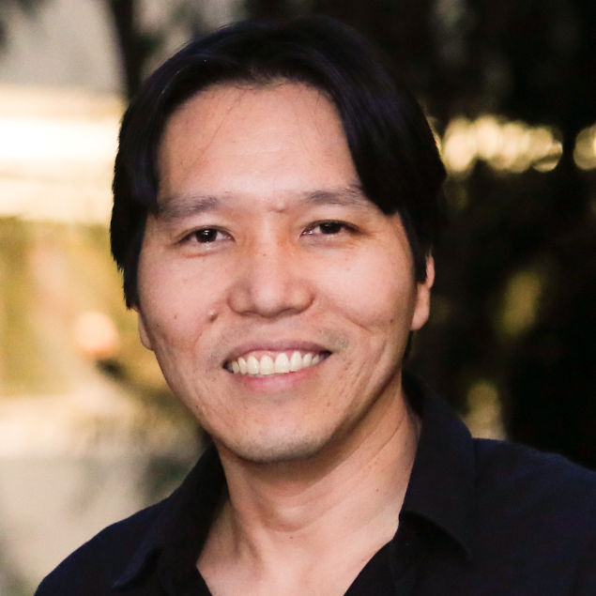 | Helder Nakaya  Associate Professor, Universidade de São Paulo;  Senior Researcher Hospital Israelita Albert Einstein  Helder Nakaya is an Associate Professor at the University of São Paulo and a Senior Researcher at Hospital Israelita Albert Einstein in Brazil, with additional teaching roles at Emory University and the University of Oxford. His research focuses on systems immunology, using large-scale biological data, network analysis and machine learning to understand immune responses, particularly in infectious diseases and vaccination, including work on predicting vaccine-induced immunity for diseases such as yellow fever.
 | Veda Storey  Professor of Computer Information Systems and Computer Science, Georgia State University  Veda C. Storey is Tull Professor of Computer Information Systems and Professor of Computer Science at Georgia State University. Her research interests are in data management, modelling, and design science research. She is particularly interested in the assessment of the impact of new and emerging technologies, including AI systems, on business and society. She plays an active role in editorial leadership and mentoring early career researchers.

Thursday 11th June, 9:00–10:00 AM EDT
Ellie Gendle
Head of Journals Policy – Research Integrity, Springer Nature

Ellie Gendle joined Springer Nature in 2023 as Head of Performance in the Research Integrity Group, before becoming Head of Journal Policy the following year. She leads the strategic direction of journal editorial policies, overseeing their development, implementation and ongoing compliance. Her work includes shaping Springer Nature policies in response to emerging challenges in scholarly publishing, including responsible use of AI in research and writing.

 | Oliver Graydon  Chief Editor, Nature Photonics  Oliver Graydon is Chief Editor of Nature Photonics. He joined the Nature Publishing Group (now Springer Nature) in 2006 to launch the journal. Oliver has a PhD in optical communications from the University of Southampton’s Optoelectronics Research Centre. He is also a Fellow of Optica. In his editorial role, he oversees the editorial operations at Nature Photonics and pays close attention to how AI-based tools are being applied and evaluated in high-impact publishing.
 | Samraat Pawar​  Professor of Theoretical Ecology, Imperial College London  Samraat Pawar is a Professor of Theoretical Ecology at Imperial College London. His research explores ecological and evolutionary dynamics using mathematical modelling and analyses of large datasets. This includes computational approaches to understanding biological systems. As part of Imperial’s quantitative ecology and AI research community, Samraat is also actively involved in training researchers in data-driven modelling in ecology and evolution.
 | Nicki Tiffin  Professor, University of the Western Cape;  Deputy Director, South African National Bioinformatics Institute  Nicki Tiffin is a Professor at the University of the Western Cape. Her research integrates genomics, epidemiological and routine health data using bioinformatics to better understand disease in African populations. She also works on ethics and data governance, developing tools to support responsible research. Nicki applies AI to harmonise and analyse large health datasets, as well as in day-to-day research and administrative tasks. She is a Calestous Juma Science Leadership Fellow with the Bill & Melinda Gates Foundation.

